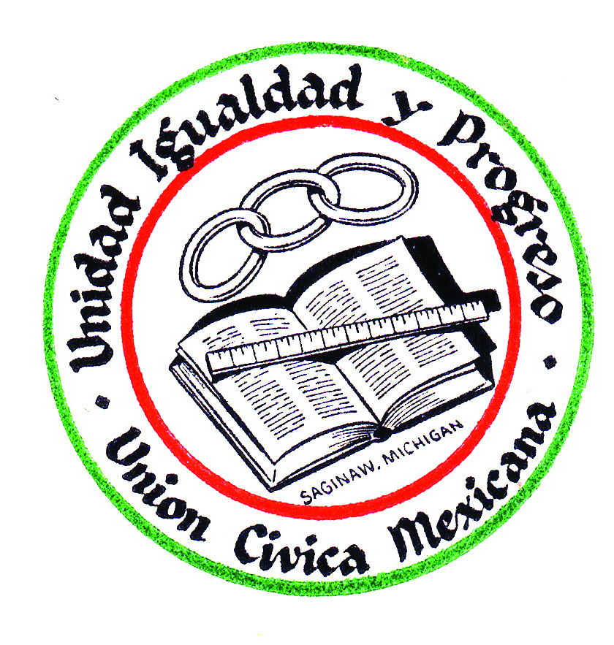
La Unión Cívica Mexicana
2023 Queen Application

Name: ________________________________________________________________________

Address: ______________________________________________________________________
Date of Birth: _________________________________ Age: _____________________________
Phone Number: _______________________________Cell:______________________________
Email: ________________________________________________________________________
Occupation and/or School: ________________________________________________________
List the names of organizations that you have been, and are, involved in:
Organization: _____________________________________ Position: _____________________
Involvement: __________________________________________________________________
Organization: _____________________________________ Position: _____________________
Involvement: __________________________________________________________________
Please include the following checklist along with all documentation for full consideration and delivered or mailed to Union Cívica Mexicana, 2715 Wadsworth, Saginaw, MI 48601:
_____All applicants must be 18- 25 years of age
_____ A biography on yourself, education, work experience, accomplishments and goals.
_____ Official transcripts showing a 2.5 grade point average or higher
_____ An essay on: “Why I would like to be the next Cívica Queen” 1 page-12 font, double spaced
_____ Current Self Photo

Application deadline is Friday, November 3, 2023, with a tentative interview schedule date of November 7 & 8, 2023. If you have any questions please contact Theresa Castillo at
(989) 482-9570 or Mary Hernandez Silvas at (989) 907-9967.

